**VistA Adaptive Maintenance VAEC Security**

**(VAM)**

Monthly Progress Report  
CLIN 0001AB



Department of Veterans Affairs

Office of Information & Technology

Contract No: VA118-16-D-1009

task Order: 36C10B19F10090015

Deliverables: CLIN0001AB

Date: May 03, 2019

Version 1.2

.

PAGE INTENTIONALLY LEFT BLANK

Revision History

Note: The revision history cycle begins when changes or enhancements are requested after the document has been baselined.

| Date | Version | Description | Author |
| --- | --- | --- | --- |
| March 04, 2019 | 1.0 | Initial Monthly Progress Report Template | AbleVets |
| April 03, 2019 | 1.1 | Monthly Progress Report for month of March 2019 | AbleVets |
| May 03, 2019 | 1.2 | Monthly Progress Report for month of April 2019 | AbleVets |
|  |  |  |  |
|  |  |  |  |
|  |  |  |  |
|  |  |  |  |
|  |  |  |  |
|  |  |  |  |
|  |  |  |  |
|  |  |  |  |

Table of Contents

1. Introduction 1

2. Work Completed During Reporting Period 1

Diagram 1: VAM Architecture diagram with Security Boundaries and Data Flow Diagram 3

Table 1: Data Flow 3

3. Work Planned for Subsequent Reporting Period 4

4. Issues and Risks 4

5. Itemized List of All Electronic and Information Technology (EIT) Deliverables 5

# Introduction

The VistA Adaptive Maintenance system is a Cloud-Smart / Cloud-Native application developed and deployed in the dedicated U.S. FedRAMP-HIGH, HIPAA-compliant VA Enterprise Cloud (VAEC) leveraging Amazon Web Services (AWS) commercial cloud infrastructure and services.  VAM provides comprehensive, commercial cloud-based monitoring and security for all clients, applications, and users that access VistA data using VistA’s Remote Procedure Call (RPC) interface.  VAM is operationalized and scaled for production enterprise’s use in the VAEC leveraging AWS Kinesis, and provides comprehensive commercial cloud-based VistA RPC Interface monitoring and security for all VistA systems migrated to the VAEC.  VAM is 100%  Legacy-free, Cloud-Native, and Non-invasive - allowing it to be scaled and deployed enterprise-wide without any change to any VistA system required.

This report covers the Period of Performance (POP) from April 01, 2019 through April 30, 2019 for the VistA Adaptive Maintenance VAEC Security (VAM) Project.

# Work Completed During Reporting Period

* Facilitatedmultiple VistA Adaptive Maintenance VAEC Security (VAM) Weekly Project Meetings to discuss status of management and technical team’s progress. The link to the meeting minutes is below: [https://github.com/vistadataproject/VAMProjectManagement/tree/master/Documents/weekly_meeting_minutes](https://github.com/vistadataproject/VAM2ProjectManagement/tree/master/Documents/weekly_meeting_minutes)
* Delivered Version D3 - **MUMPS Code I** (RPC Broker fixed behaviors): Examined and tested RPC Broker code to scope [a] RPC Parsing requirements, [b] session recognition and stateful behavior required of the RPC Monitor and [c] vulnerabilities in the existing broker on April 26, 2019.
* Updated Risk Vision profile for VAM; updated the details for the new scope and added new team members to old profile and dropped old team members from the new profile etc.
* Delivered the following documents:
  + CLIN 0001AA – Contractor Project Management Plan (CPMP) Ver 1.1
  + CLIN 0001AB – Monthly Progress Report Ver 1.1
  + CLIN 0001AC – VA Privacy and Information Security Awareness
  + CLIN 0001AD – Contract Rules of Behavior
  + CLIN 0001AE – VA HIPAA Certificates
  + CLIN 0001AF – Weekly Onboarding Status Report
  + CLIN0003AA – Master Test Plan Ver 1.1
* Reviewed and updated al Risk Vision Templates and Controls questions and submitted to Dr. Richards, SO, ISO, PM, and PO for their review and signatures where applicable.
* Working on creating and updating, reviewing and getting final signatures on the following documents from Dr. Richards, SO, ISO, PO, and PM, wehre applicable, in preparation for the ATO submission:
  + PTA – Privacy Threshold Analysis
  + DRP – Disaster Recovery Plan
  + RA – Risk Assessment
  + BIA – Business Impact Analysis
  + CMP – Configuration Management Plan
  + IRP – Incidence Response Plan
  + SDD – System Design Document
  + SIA – Security Impact Analysis
  + SSC – System Security Categorization Report
  + SOA – System Owner Attesstation
  + SOR – System Owner Responsibilties
  + PIA – Privacy Impact Assessment
  + ISCP – Informaton Security Contingency Plan
  + SSP – System Security Plan
  + SA – Signatory Authority
* Working on creating the following CLIN documents that are due on 05-02-2019:

|  |  |  |
| --- | --- | --- |
|  | **CLIN** | **DESCRIPTION** |
| 1 | 0002AA | Comprehensive RPC Interface Audit Report in accordance with PWS Paragraph 5.2. |
| 2 | 0002AB | Massachusetts General Hospital Utility Multi-Programming System (MUMPS) remote procedure call RPC to JSON Model Data Definition in accordance with PWS Paragraph 5.2. |
| 3 | 0002AC | Version Description Document (VDD) in accordance with PWS Paragraph 5.2. |
| 4 | 0002AD | Automated CloudWatch Configuration in accordance with PWS Paragraph 5.2. |
| 5 | 0002AE | Security Vulnerability Report in accordance with PWS Paragraph 5.2. |
| 6 | 0003AB | RPC Interface Test Suite |
| 7 | 0005AA | Production Operations Manual (POM) in accordance with PWS Paragraph 5.5. |
| 8 | 0005AB | Deployment and Installation Guide in accordance with PWS Paragraph 5.5. |
| 9 | 0005AC | User Manual in accordance with PWS Paragraph 5.5. |

* Updated the New Architecture Diagram to depict the system boundary and the data flow (See Diagram Below).

#### Diagram 1: VAM Architecture diagram with Security Boundaries and Data Flow Diagram

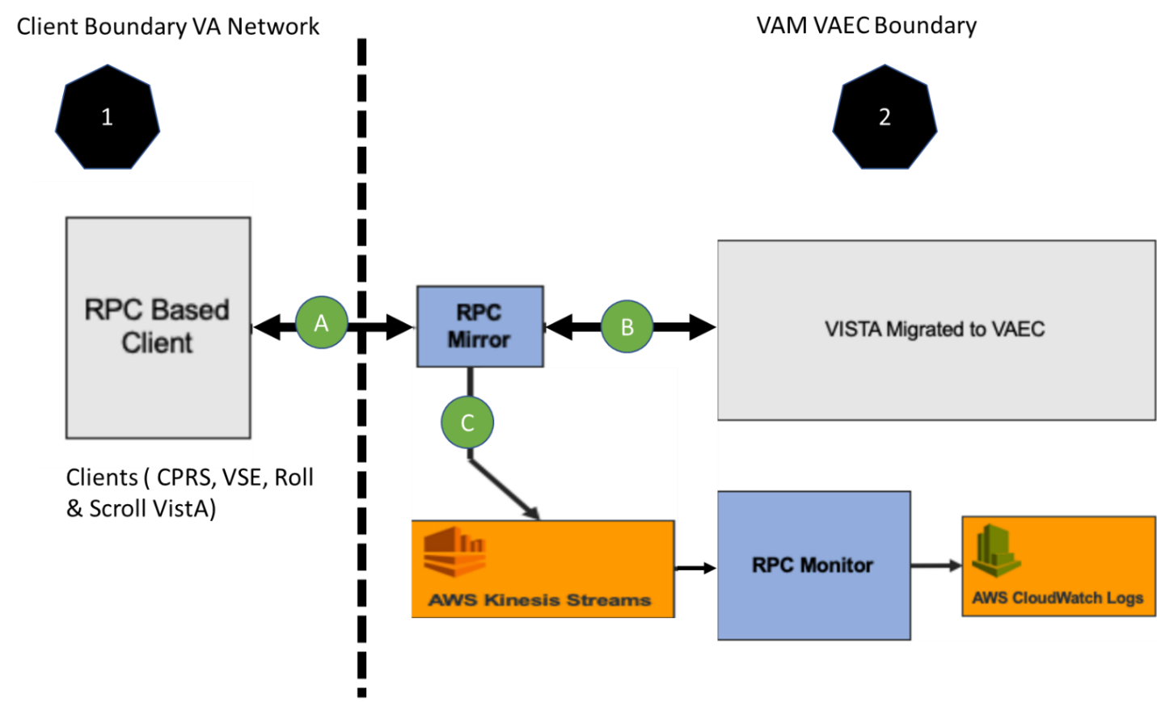

#### Table 1: Data Flow

|  |  |  |
| --- | --- | --- |
| **ID** | **Data Flow Link** | **Description** |
| A | Client to and from RPC Mirror | Data flows between Client and RPC Mirror bi-directionally. This link carries RPC Calls, Meta Data and de-identified PII/PHI data. This is the only link which will cross between VA Network to VAEC AWS Boundary. |
| B | RPC Mirror to and from VistA | Data flows between RPC Mirror and VistA bi-directionally. This link directs all traffic from RPC Mirror to VistA and responses from VistA back to RPC Mirror. |
| C | RPC Mirror to VAM Application | Data flows from RPC Mirror to VAM Application unidirectionally. This data parsed using VAM (AWS Kinesis Streams, RPC Monitor and AWS CloudWatch Logs) to provide audit results in CloudWatch. |

# Work Planned for Subsequent Reporting Period

* Continue to work on updating the Risk Vision and Risk Vision Templates in accordance to the scope of VAM and submit the same for the ATO.

# Issues and Risks

The following issues must be resolved prior to delivery of the Dev-Int Build 4:

|  |  |  |  |  |  |
| --- | --- | --- | --- | --- | --- |
| Issue Category | Issue Description | Issue Number | Due  Date | Risk Identified | Mitigation Plan |
| Technical | Receive ATO | VAM-R10 (ATO Dashboard) | 8/30/2019 | ATO will be required before we go to IOC Production | Risk Vision instance for VAM has been updated with VAM VAEC Security scope (VAM).  AbleVets team has prepared the ATO submission documents based on guidance from weekly meetings with Bobbi (ISO) and Cheryl (VA PM). |
| Technical | Obtain / Configure VAEC IOC Environnements | VAM-R17(IOC Dashboard) | 10/31/2019 | Need Configured VAEC IOC prior to Delivery of Dev-Int Build 4 | Valley Coastal, TX and Omaha Vista identified on 03-21-2019 meeting for VAM. We are working to get the identified IOC VistA environments migrated to VAEC and establish connectivity. |
| Release Process | Identify a release manager and process using GitHub | VAM-R18(PWS Dashboard) | 06/06/2019 | As per the PWS, we are using GitHub for releasing VAM. | Need to identify the release Manager  Setup meeting to discuss the release process using GitHub. |

# Itemized List of All Electronic and Information Technology (EIT) Deliverables

* + CLIN 0001AA – Contractor Project Management Plan (CPMP) Ver 1.1
  + CLIN 0001AB – Monthly Progress Report Ver 1.1
  + CLIN 0001AC – VA Privacy and Information Security Awareness
  + CLIN 0001AD – Contract Rules of Behavior
  + CLIN 0001AE – VA HIPAA Certificates
  + CLIN 0001AF – Weekly Onboarding Status Report
  + CLIN0003AA – Master Test Plan Ver 1.1